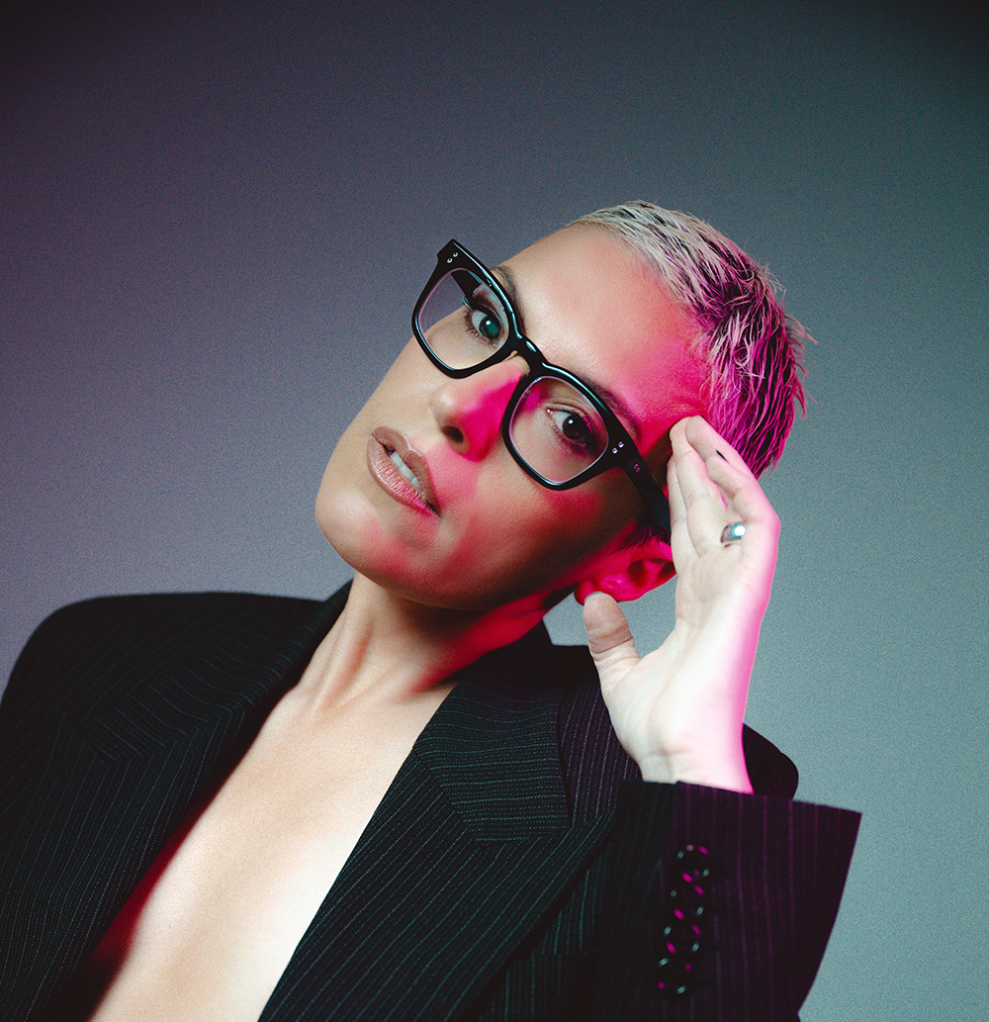
SELECTED CREDITS
SWEET MILK LAKE (2026)

MIX TAPE (2025)

PLUM (2024)

HEARTBREAK HIGH (2022-2025)

PANOPTICON (2023)

TOTALLY COMPLETELY FINE (2023)

BIOGRAPHY
Chiara is a film and TV composer and electronic producer based between Melbourne and Torino, holding dual Australian and Italian citizenship. Her diverse career spans screen composition, electronic music, and sound design, blending classical training with cutting-edge electronic exploration.
She has recently composed music for Netflix’s global hit ’Heartbreak High’, ’Panopticon’ (Karlovy Vary International Film Festival 2024), and ’Inside’ starring Guy Pearce and Cosmo Jarvis (Tribeca 2025). One of her latest projects, ’Mixtape’ (SXSW 2025), premiered on Binge, Foxtel, and the BBC in June 2025. Other notable TV projects include ’Totally Completely Fine’ (STAN Original) and ’The Unusual Suspects’ (SBS), while her film credits include Australia’s ’Open’ (MIFF/ABC), ’Long Story Short’, and the Palme D’Or-winning short ’All These Creatures’ (Cannes, 2018).
Beyond screen composition, Chiara has collaborated with renowned choreographers and visual artists, including contemporary dance companies Chunky Move and Prue Lang, as well as visual artists Callum Morton and Kris Moyes, creating dynamic, multidisciplinary soundscapes.
Classically trained in piano, Chiara transitioned into electronic music after relocating to Melbourne in 2004. She developed a refined DJing style under the moniker Chiara Kickdrum, performing at festivals such as Pitch, Meredith, and Dark Mofo, and supporting acts including Kiasmos, Underground Resistance, and Nina Kraviz. Her sound design expertise also extends to fashion, composing for designers Henne and Dion Lee.
Chiara studied sound art and design at RMIT University and now lectures in Interactive Composition at RMIT and the Melbourne Conservatorium of Music. Her work spans scoring for screen, live electronic performance, immersive soundscapes, and experimental field recordings. In 2020, she received the APRA Mentorship for Women in Screen Composition, working closely with composer Bryony Marks.

FILM COMPOSER CREDITS

Sweet Milk Lake (2026)
Directed by Rhys Graham and Havey Zielinski
Film Camp

Silenced (2026)
Directed by Selina Miles
Stranger than Fiction Films

Penny Lane is Dead (2025)
Directed by Mia Kate Russell
Sanctuary Pictures Productions

Sweet Milk Lake (2025)
Directed by Harvey Zielinski
Film Camp Productions

Inside (2024)
Directed by Charles Williams
Finnish Impact Filmfund

Panopticon (2023)
Directed by George Sikharulidze
20 Steps Productions

My Summer in the Human Resistance (Short) (2023)
Directed by Steve Anthopoulos
Spaceboy Productions

Australia’s Open (2023)
Directed by Ili Bare
Good Thing Production Company

Bienvenidos a Los Angeles (2022)
Directed by Lisa Cole
3rd Astronaut

The Land of Nod (Short) (2022)
Directed by Josh Massarotti
Exodus Film

A Christmas Ransom (2022)
Directed by Adele Vuko
Stan

Victim (2022)
Directed by Robin Summons
Munition Pictures
Occupation (2021)
Directed by Robin Summons
Backer Films

Vampyr (Live Score 2022)
Directed by Carl Theodor Dreyer (1932)

L’Onesta del Peccato (Live Score 2021)
Directed by Augusto Genino (1918)

The Lost Season (2021)
Directed by Alexander Moore
Back Pocket Films

A Fistful of Dollars (Live Score 2021)
Directed by Sergio Leone (1964)

Long Story Short (2020)
Directed by Josh Lawson
Create NSW

Agender (Short) (2019)
Directed by Susan Earl

Chlorine (Short) (2019)
Directed by Sebastien Rabas

Before I Go (2019)
Directed by Mika Tran
The Act of Storytelling

All These Creatures (2018)
Directed by Charles Williams
Simpatico Films

The Future Memories (Short) (2014)
Directed by Pablo Muñoz Gómez
Pablander

TELEVISION COMPOSER CREDITS

Heartbreak High (2022-2025) - Seasons 1,2,3
Fremantle

Mix Tape (2025)
Directed by Lucy Gaffy
Subotica

Plum (2024)
Created by Brendan Cowell
Modern Convict Films

Totally Completely Fine (2023)
Directed by Lucy Gaffy, Adrian Chiarella
Fremantle Media

Erotic Stories (2023)
Directed by Leticia Cáceres, Madeleine Gottlieb
Lingo Pictures
Preppers (2021)
Created by Gabriel Dowrick and Nakkiah Lui
Spirit Pictures

The Unusual Suspects (2021)
Created by Jessica Redenbach
Aquarius Films

The Other Guy (2019)
Created by Matt Okine
Wooden Horse

Eurovision - Australia Decides (2019)
SBS

Kiki & Kitty (2017)
Directed by Catriona McKenzie
Porchlight Films

LIVE MEDIA

Poesis (2025)
Prue Lang (Dance)
Henne (2023)
Syndney Fashion Festival
Goddess (2023)
ACMI Exhibition (Installation)
Castillo (2022)
Prue Lang (Dance)
Yung Lung (2021)
Chunky Move (Dance)
Project F (2020)
Prue Lang (Dance)
Towards Innumerable Futures (2018)
Prue Lang (Dance)
Snake (2016)
Melbourne Fringe Festival
Dion Lee Runway Show (2016)
Melbourne Fashion Festival
Porcelana Innovadora (2014)
Installation with visual artist Kit Webster
Sound to Light (2013)
Dark Mofo (Installation)

COMMERCIALS

Adina Hotel (2021)
Pause Fest Opening Titles (2020)
Aspen & Black Diamond (2019)
Shine Lawyers (2017)
Aston Martin Rapide (2017)
BUPA (2016)
Arnott’s (2016)
Crown Golden Ale (2016)
Mitsubishi (2016)
2Degrees Mobile (2016)
Portmans (2016)
NAB Bank (2015)

